

**V1.0, 2024/09**

**Power Module**

**AEP820B08TFLTMM**

**750V HPD IGBT**

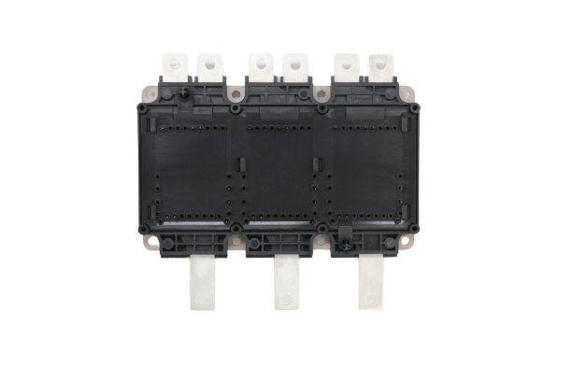

Applications

* Motor Drives
* All-Terrain Vehicles
* Automotive Applications
* Hybrid Electrical Vehicles (H) EV
* Commercial Agriculture Vehicles

|  |
| --- |
| Features  **Electrical Features** |
| 🞍 Low QG  🞍 Tj,op = 150°C  🞍 Low Inductance Design  🞍 Blocking Voltage 750V |
| 🞍 Fast and Soft Reverse Recovery  🞍 Low VCE,sat and Switching Losses |

|  |
| --- |
| **Mechanical Features** |
| 🞍 Compact Design  🞍 4.2kV DC Insulation  🞍 UL 94 Module Frame  🞍 Temperature Sensor Included |
| 🞍 Direct Water Cooling Pin-Fin Base Plate  🞍 Easy to Integrate 6-pack Topology  🞍 Pb-free Device and RoHS Compliant  🞍 Guiding Elements for PCB and Cooler Assembly |



Circuit Diagram

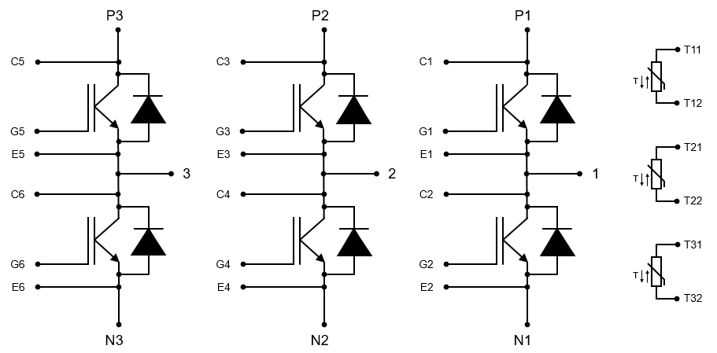



IGBT

▍**Maximum Rated Values**

|  |  |  |  |  |
| --- | --- | --- | --- | --- |
| **Parameter** | **Conditions** | **Symbol** | **Values** | **Unit** |
| Collector-emitter voltage | Tj = 25°C | VCES | 750 | V |
| Gate-emitter peak voltage |  | VGES | ±20 | V |
| Implemented collector current |  | ICN | 820 | A |
| Continuous DC collector current | TF = 70°C, Tj,max = 175°C | IC nom | 450 | A |
| Repetitive peak collector current | tp = 1 ms | ICRM | 1640 | A |
| Maximum junction temperature |  | Tj,max | 175 | oC |

**▍Characteristics Values**

|  |  |  |  |  |  |  |  |
| --- | --- | --- | --- | --- | --- | --- | --- |
| **Parameter** | **Conditions** | | **Symbol** | **Min.** | **Typ.** | **Max.** | **Unit** |
| Collector-emitter saturation voltage | IC = 450A, VGE = 15V  IC = 450A, VGE = 15V  IC = 450A, VGE = 15V | Tj = 25°C  Tj = 150°C  Tj = 175°C | VCE,sat |  | 1.15  1.25  1.30 | 1.45 | V |
| IC = 820A, VGE = 15V  IC = 820A, VGE = 15V  IC = 820A, VGE = 15V | Tj = 25°C  Tj = 150°C  Tj = 175°C |  | 1.40  1.60  1.70 |  |
| Gate threshold voltage | IC = 9.6 mA, VCE = VGE  IC = 9.6 mA, VCE = VGE  IC = 9.6 mA, VCE = VGE | Tj = 25°C  Tj = 150°C  Tj = 175°C | VGE,th | 5.10 | 5.70  4.20  3.95 | 6.50 | V |
| Collector-emitter cut-off current | VCE = 750V, VGE = 0V  VCE = 750V, VGE = 0V  VCE = 750V, VGE = 0V | Tj = 25°C  Tj = 150°C  Tj = 175°C | ICES |  |  | 1.0  5.0  10.0 | mA |
| Gate-emitter leakage current | VCE = 0V, VGE = 20V | Tj = 25°C | IGES |  |  | 400 | nA |
| Gate charge | VGE = -8V / + 15 V  IC = 450A, VCE = 400V | Tj = 25°C | QG |  | 1.8 |  | μC |
| Internal gate resistance |  | Tj = 25°C | RG,int |  | 1.7 |  | Ω |
| Input capacitance | f = 100kHz, VCE = 50V  VGE = 0V | Tj = 25°C | Cies |  | 43 |  | nF |
| Output capacitance | f = 100kHz, VCE = 50V  VGE = 0V | Tj = 25°C | Coes |  | 2.1 |  | nF |
| Reverse transfer capacitance | f = 100kHz, VCE = 50V  VGE = 0V | Tj = 25°C | Cres |  | 0.6 |  | nF |



|  |  |  |  |  |  |  |  |
| --- | --- | --- | --- | --- | --- | --- | --- |
| **Parameter** | **Conditions** | | **Symbol** | **Min.** | **Typ.** | **Max.** | **Unit** |
| Turn-on delay time, inductive load | IC = 450A, VCE = 400V  VGE = -8V / + 15V  RG,on = 2.5 Ω | Tj = 25°C  Tj = 150°C  Tj = 175°C | td(on) |  | 0.14  0.11  0.11 |  | μs |
| Rise time, inductive load | IC = 450A, VCE = 400V  VGE = -8V / + 15V  RG,on = 2.5 Ω | Tj = 25°C  Tj = 150°C  Tj = 175°C | tr |  | 0.069  0.070  0.072 |  | μs |
| Turn-on energy loss per pulse | IC = 450A, VCE = 400V  LS = 30nH  VGE = -8V / + 15V  RG,on = 2.5 Ω  di/dt = 5.5 A/ns (25°C)  di/dt = 5.1 A/ns (150°C) | Tj = 25°C  Tj = 150°C  Tj = 175°C | Eon |  | 8.7  12.5  13.2 |  | mJ |
| Turn-off delay time, inductive load | IC = 450A, VCE = 400V  VGE = -8V / + 15V  RG,off = 5.0 Ω | Tj = 25°C  Tj = 150°C  Tj = 175°C | td(off) |  | 0.55  0.56  0.57 |  | μs |
| Fall time, inductive load | IC = 450A, VCE = 400V  VGE = -8V / + 15V  RG,off = 5.0 Ω | Tj = 25°C  Tj = 150°C  Tj = 175°C | tf |  | 0.27  0.42  0.45 |  | μs |
| Turn-off energy loss per pulse | IC = 450A, VCE = 400V  LS = 30nH  VGE = -8V / + 15V  RG,off = 5.0 Ω  dv/dt = 2.5 V/ns (25°C)  dv/dt = 2.2 V/ns (150°C) | Tj = 25°C  Tj = 150°C  Tj = 175°C | Eoff |  | 30.5  40.5  44.7 |  | mJ |
| Short circuit current | VGE = 15 V, VCC = 400V  tp = 6 μs tp = 3 μs | Tj = 25°C  Tj = 175°C | ISC |  | 4800  3800 |  | A |
| Thermal resistance, junction to cooling fluid | Per IGBT  dV/dT = 10 dm3/min  TF = 70°C |  | Rth,JF |  | 0.120 | 0.140 | K/W |
| Operated temperature condition |  |  | Tj,op | -40 |  | 150 | °C |



Diode

**▍Maximum Rated Values**

|  |  |  |  |  |
| --- | --- | --- | --- | --- |
| **Parameter** | **Conditions** | **Symbol** | **Values** | **Unit** |
| Repetitive peak reverse voltage | Tj = 25°C | VRRM | 750 | V |
| Implemented forward current |  | IFN | 820 | A |
| Continuous DC forward current | TF = 70°C, Tj,max = 175°C | IF | 450 | A |
| Repetitive peak forward current | tp = 1 ms | IFRM | 1640 | A |

**▍Characteristics Values**

|  |  |  |  |  |  |  |
| --- | --- | --- | --- | --- | --- | --- |
| **Parameter** | **Conditions** | | **Symbol** | **Typ.** | **Max.** | **Unit** |
| Forward voltage | IF = 450A, VGE = 0V  IF = 450A, VGE = 0V  IF = 450A, VGE = 0V | Tj = 25°C  Tj = 150°C  Tj = 175°C | VF | 1.45  1.50  1.55 | 1.65 | V |
| IF = 820A, VGE = 0V  IF = 820A, VGE = 0V  IF = 820A, VGE = 0V | Tj = 25°C  Tj = 150°C  Tj = 175°C | 1.80  1.85  1.90 |  |
| Peak reverse recovery current | IF = 450A, VR = 400V  VGE = -8V  -diF/dt = 5.0 A/ns (25°C)  -diF/dt = 4.1 A/ns (150°C) | Tj = 25°C  Tj = 150°C  Tj = 175°C | IRM | 225  275  290 |  | A |
| Recovered charge | IF = 450A, VR = 400V  VGE = -8V  -diF/dt = 5.0 A/ns (25°C)  -diF/dt = 4.1 A/ns (150°C) | Tj = 25°C  Tj = 150°C  Tj = 175°C | Qrr | 12.5  31.3  35.8 |  | μC |
| Reverse recovery energy | IF = 450A, VR = 400V  VGE = -8V  -diF/dt = 5.0 A/ns (25°C)  -diF/dt = 4.1 A/ns (150°C) | Tj = 25°C  Tj = 150°C  Tj = 175°C | Erec | 3.5  7.7  9.1 |  | mJ |
| Thermal resistance, junction to cooling fluid | Per diode  dV/dT = 10 dm3/min  TF = 70°C |  | Rth,JF | 0.175 | 0.200 | K/W |

NTC-Thermistor

|  |  |  |  |  |  |  |
| --- | --- | --- | --- | --- | --- | --- |
| **Parameter** | **Conditions** | **Symbol** | **Min.** | **Typ.** | **Max.** | **Unit** |
| Rated resistance | Tc = 25°C | R25 |  | 5.0 |  | kΩ |
| Resistance tolerance | Tc = 100°C, R100 = 493 Ω | ΔR/R | -5 |  | 5 | % |
| B-value | R2 = R25 exp [B25/50(1/T2 – 1/(298 K))] | B25/50 |  | 3375 |  | K |
| B-value | R2 = R25 exp [B25/80(1/T2 – 1/(298 K))] | B25/80 |  | 3411 |  | K |
| B-value | R2 = R25 exp [B25/100(1/T2 – 1/(298 K))] | B25/100 |  | 3433 |  | K |

Module

|  |  |  |  |  |
| --- | --- | --- | --- | --- |
| **Parameter** | **Conditions** | **Symbol** | **Value** | **Unit** |
| Isolation test voltage | RMS, f = 0 Hz, t = 1 sec | VISOL | 4.2 | kV |
| Module baseplate material |  |  | Cu + Ni |  |
| Module internal isolation material | Basic isolation (class 1, IEC 61140) |  | Al2O3 |  |
| Creepage distance | Terminal to heatsink | dCreep,TH | 9.0 | mm |
| Creepage distance | Terminal to terminal | dCreep,TT | 9.0 | mm |
| Clearance distance | Terminal to heatsink | dClear,TH | 4.5 | mm |
| Clearance distance | Terminal to terminal | dClear,TT | 4.5 | mm |
| Comparative tracking index 1) |  | CTI | > 200 |  |

|  |  |  |  |  |  |  |
| --- | --- | --- | --- | --- | --- | --- |
| **Parameter** | **Conditions** | **Symbol** | **Min.** | **Typ.** | **Max.** | **Unit** |
| Module stray inductance |  | LsCE |  | 7 |  | nH |
| Storage temperature |  | Tstg | -40 |  | 125 | °C |
| Mounting torque for module  mounting | Screw M4 baseplate to heatsink | M | 1.80 | 2.00 |  | Nm |
| Weight |  | G |  | 750 |  | g |

1. Extracted by following UL 746A

Characteristics Diagrams

IGBT, Output characteristics

VGE = 15V, IC = f(VCE)

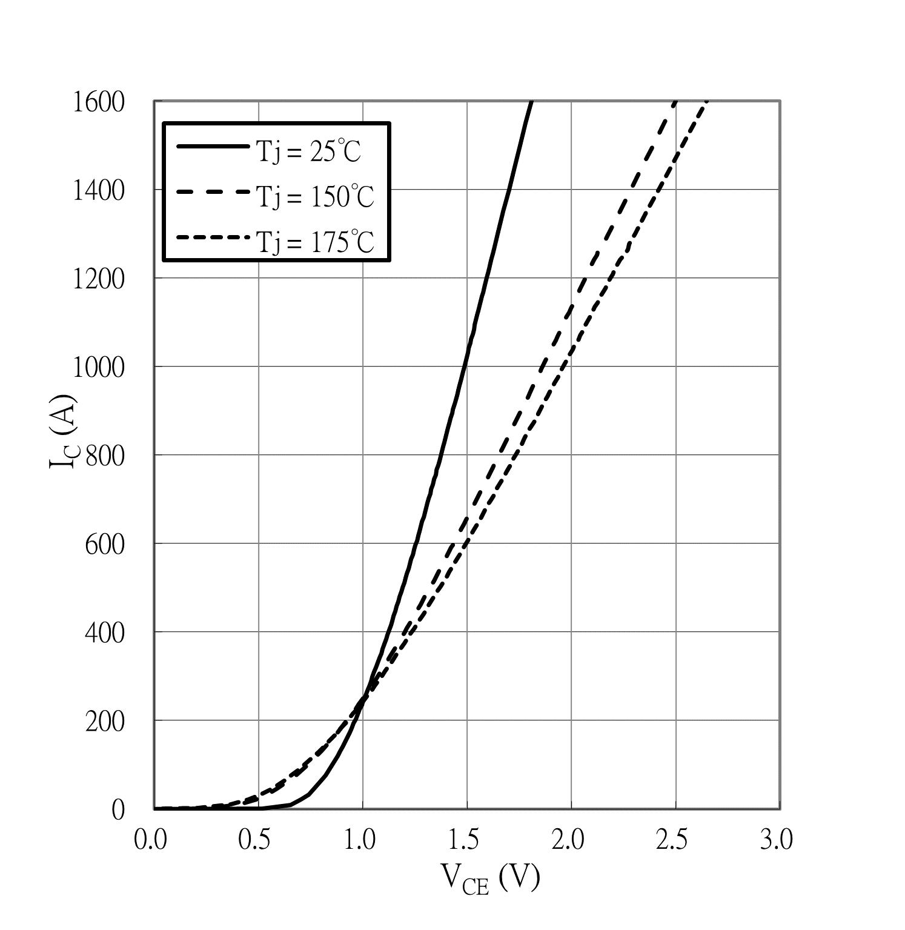

IGBT, Output characteristics

Tj = 25°C, IC = f(VCE)

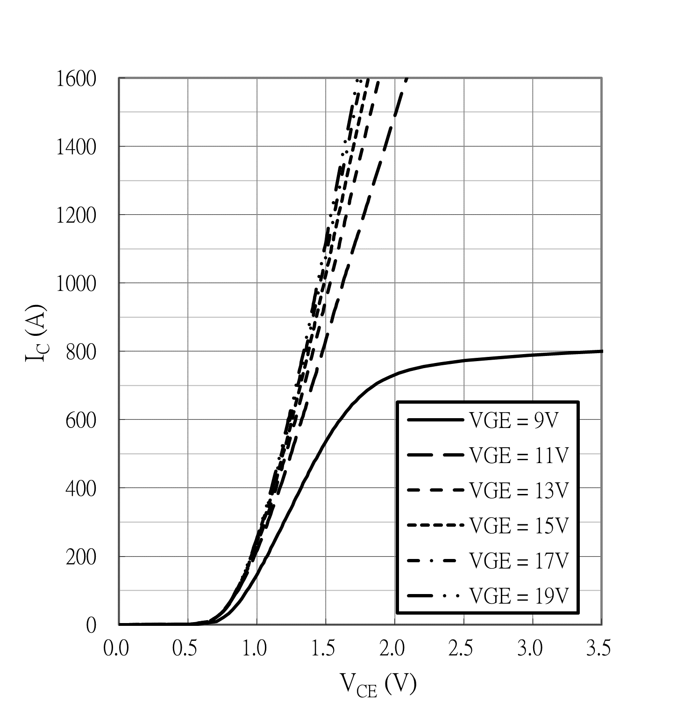

IGBT, Output characteristics

Tj = 150°C, IC = f(VCE)

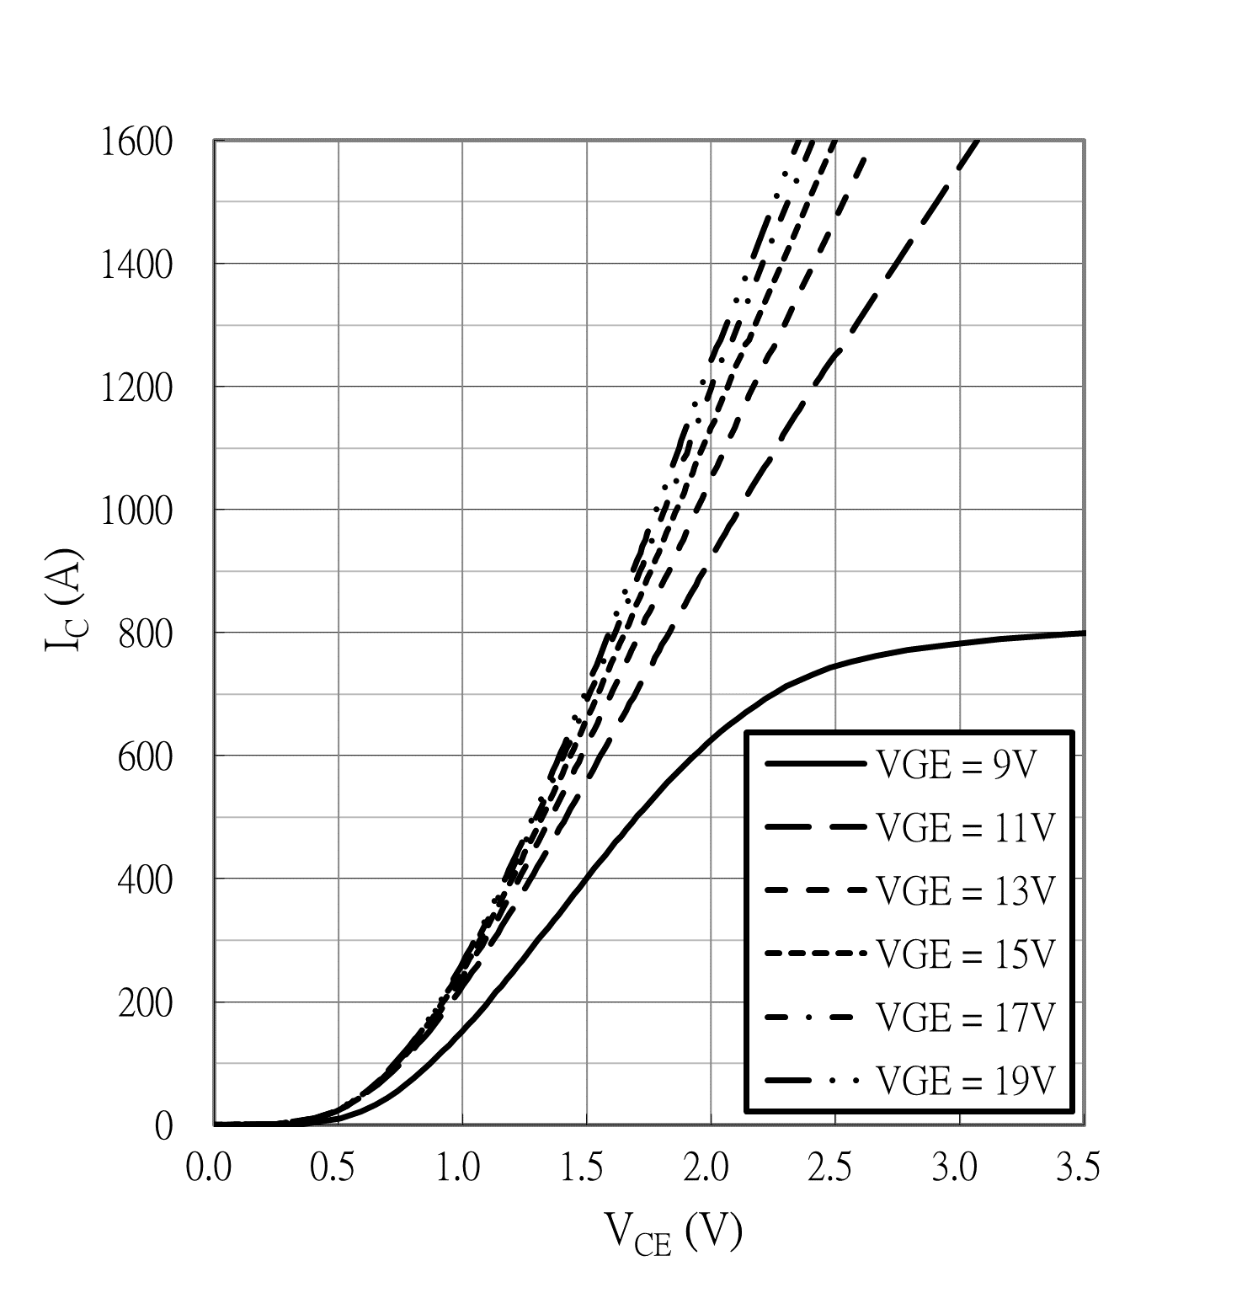

Diode, Forward characteristics

If = f(VF)

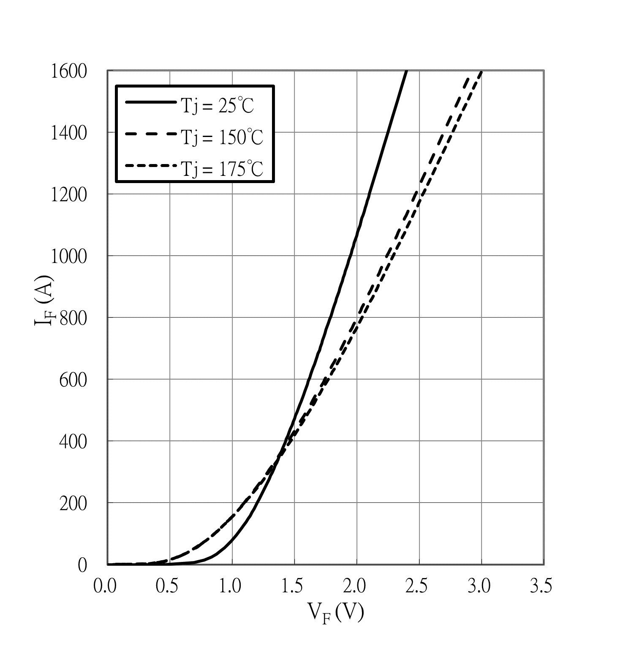



NTC-Thermistor-temperature characteristics

R = f(TNTC)

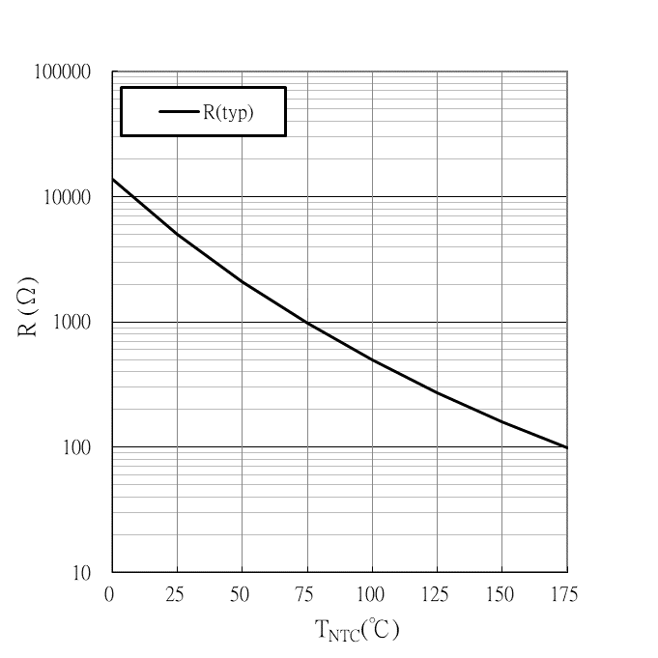

IGBT, Switching losses vs. RG

VGE = -8V / + 15V, VCE = 400V, IC = 450A

Eon & Eoff = f(RG)

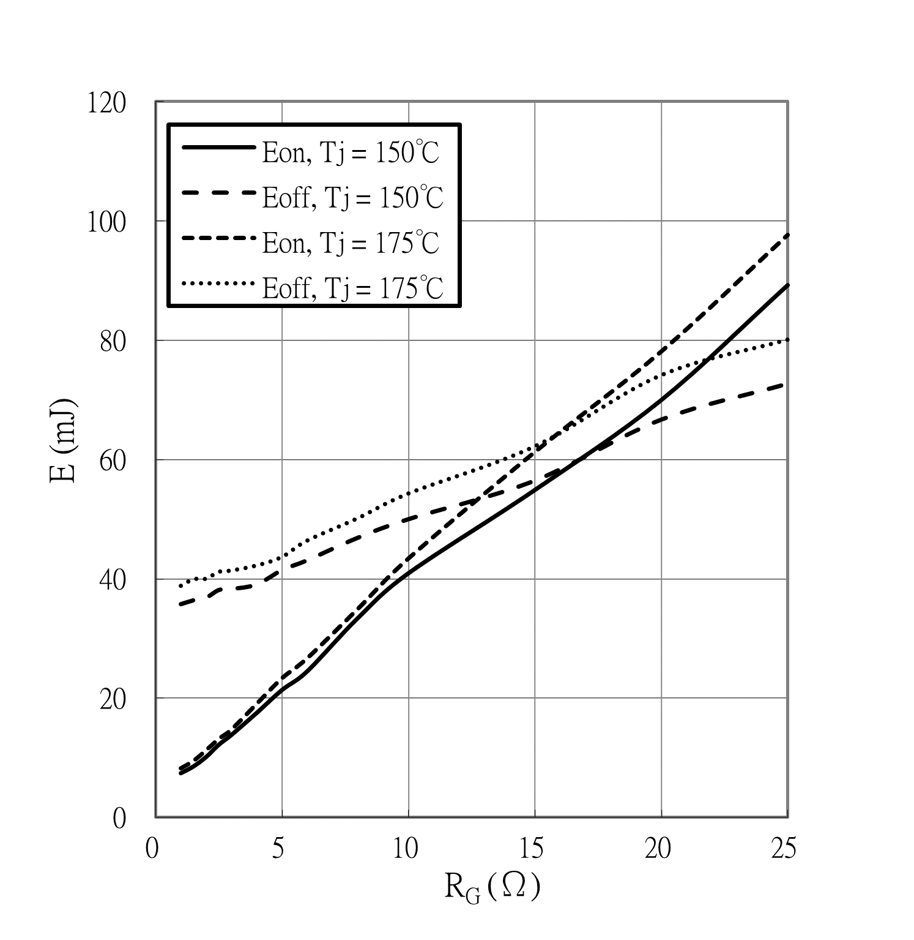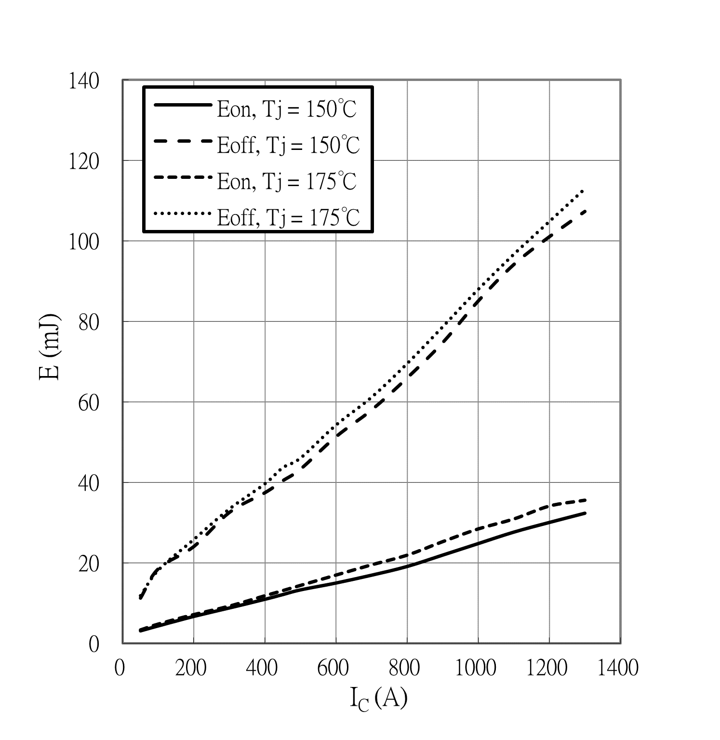

IGBT, Switching losses vs. IC

VGE = -8V / + 15V, RG,on = 2.5 Ω

RG,off = 5.0 Ω, VCE = 400V, Eon & Eoff = f(Ic)

IGBT, Capacitance characteristics s

VGE = 0V, Tj = 25°C, f = 100 kHz, C = f(VCE)

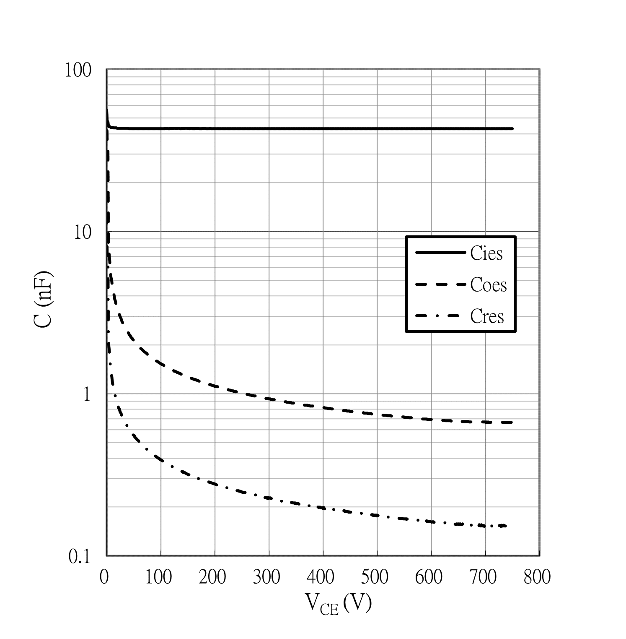



Reverse bias safe operating area (RBSOA)

VGE = -8V / + 15V, RG,off = 5.0 Ω, Tj = 175°C

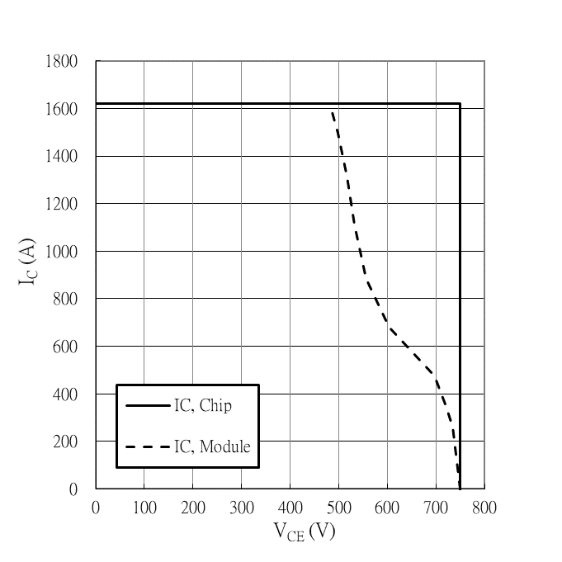

Diode, Switching losses vs. IF

RG = 2.5 Ω, VR = 400V, Erec = f(IF)

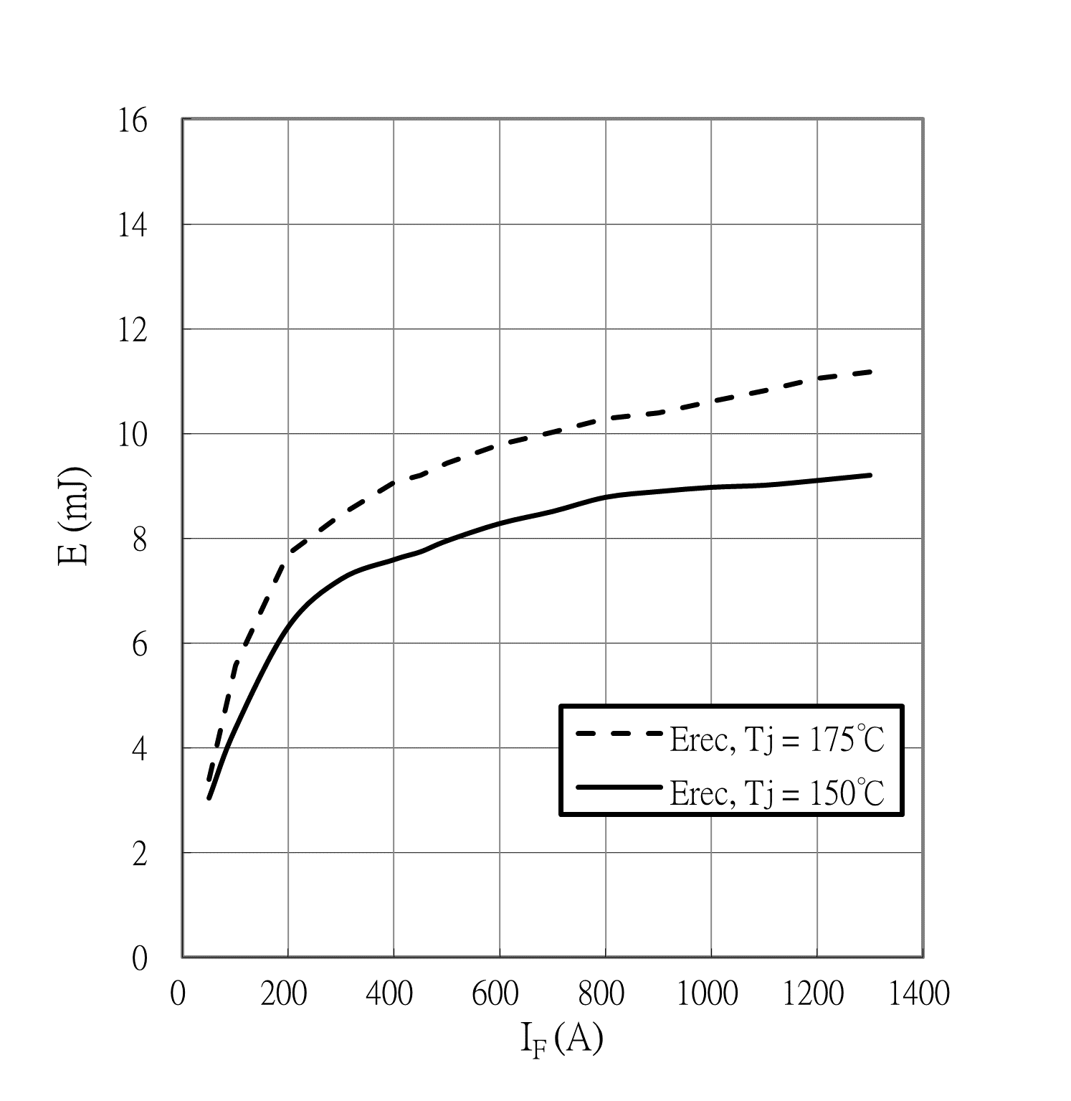

IGBT Total gate charge characteristic

VCE = 400V, IC = 450A, Tj = 25°C

VGE = f(QG)

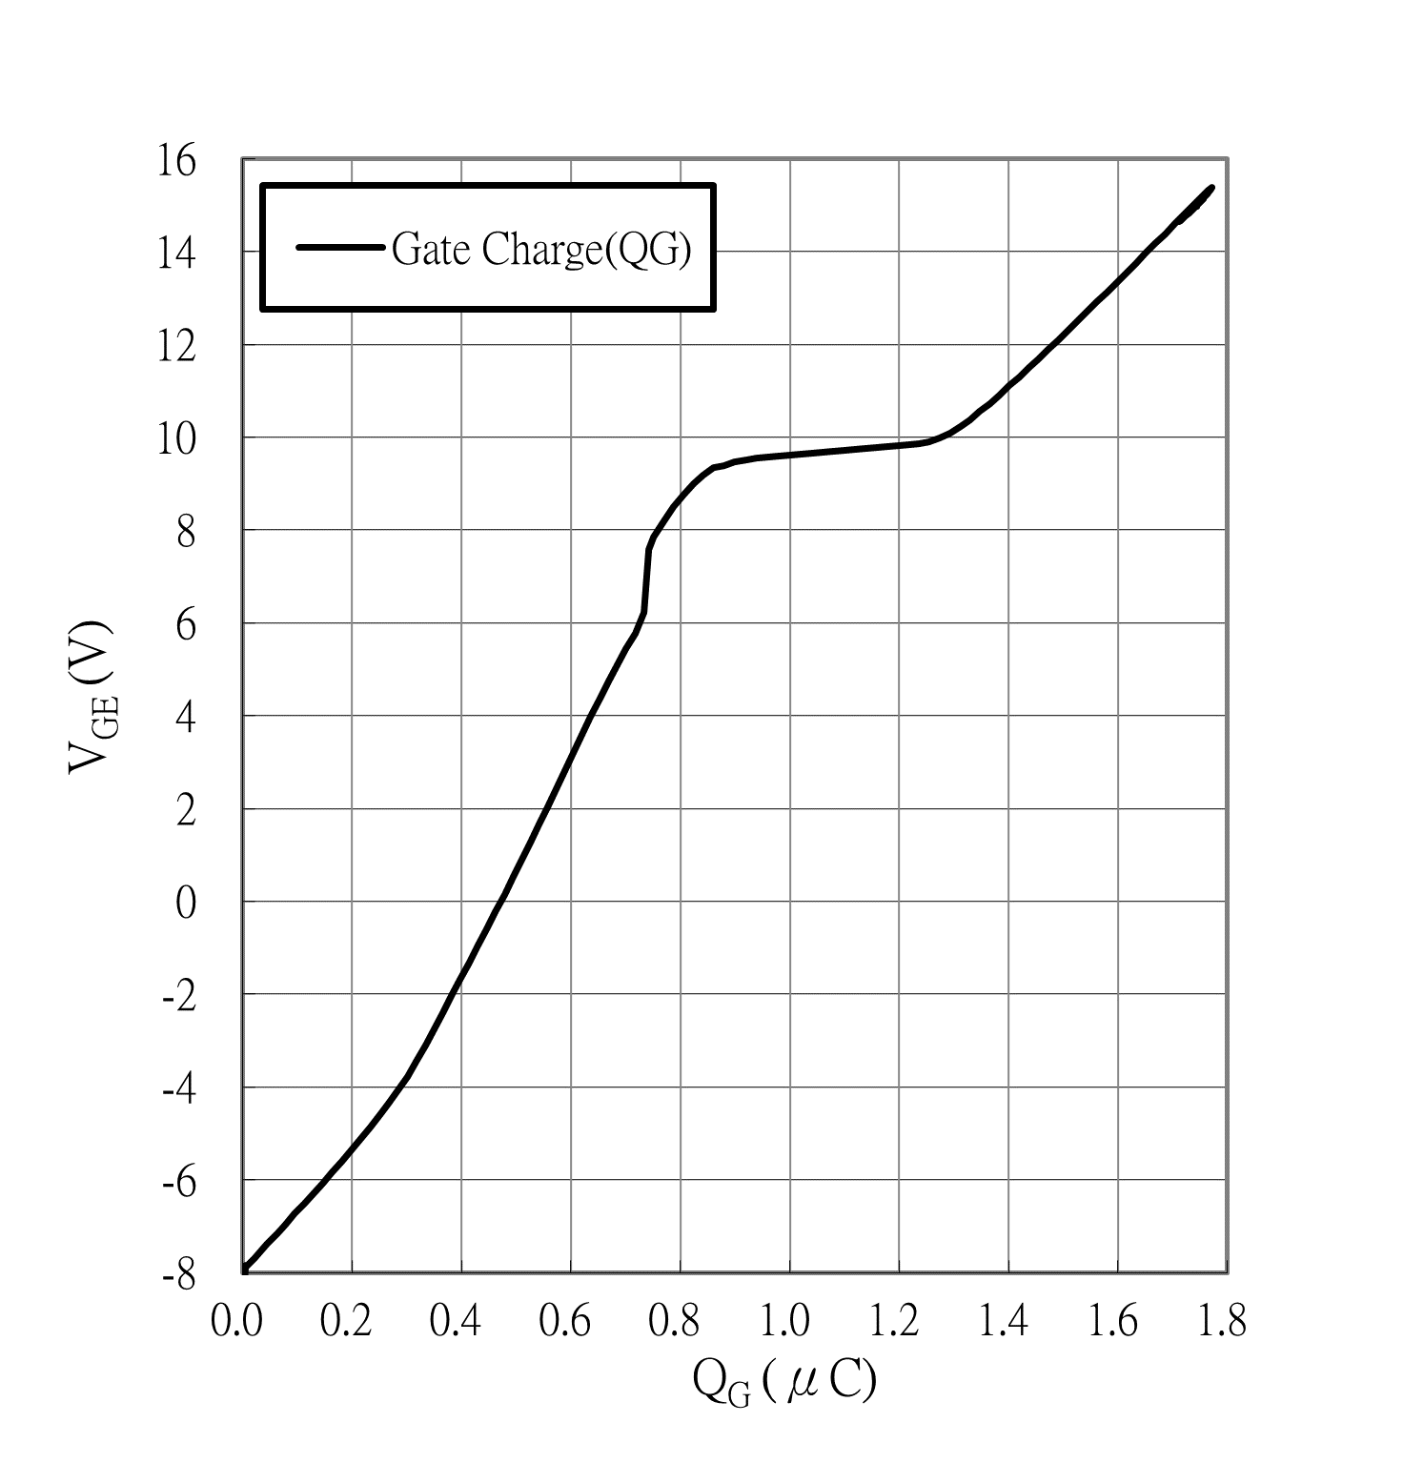

Diode, Switching losses vs. RG

IF = 450A, VR = 400V, Erec = f(RG)

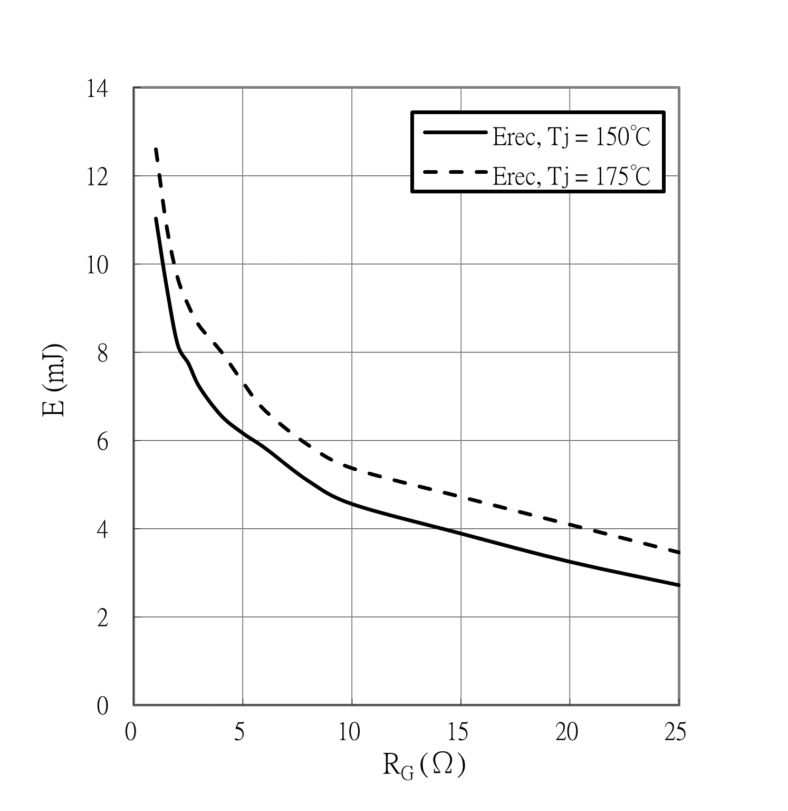

IGBT Transient thermal impedance

ZthJF = f(tP)

ΔV/Δt = 10 dm3/min, TF = 70°C

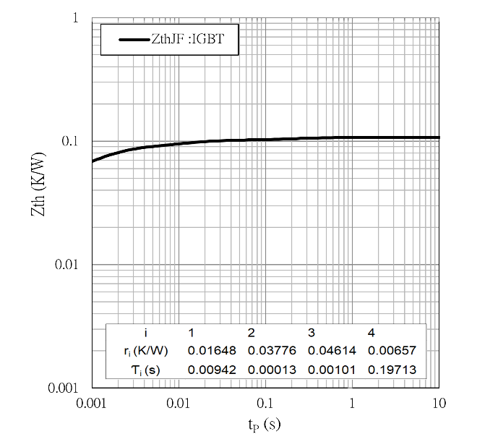

Diode Transient thermal impedance

ZthJF = f(tP)

ΔV/Δt = 10 dm3/min, TF = 70°C

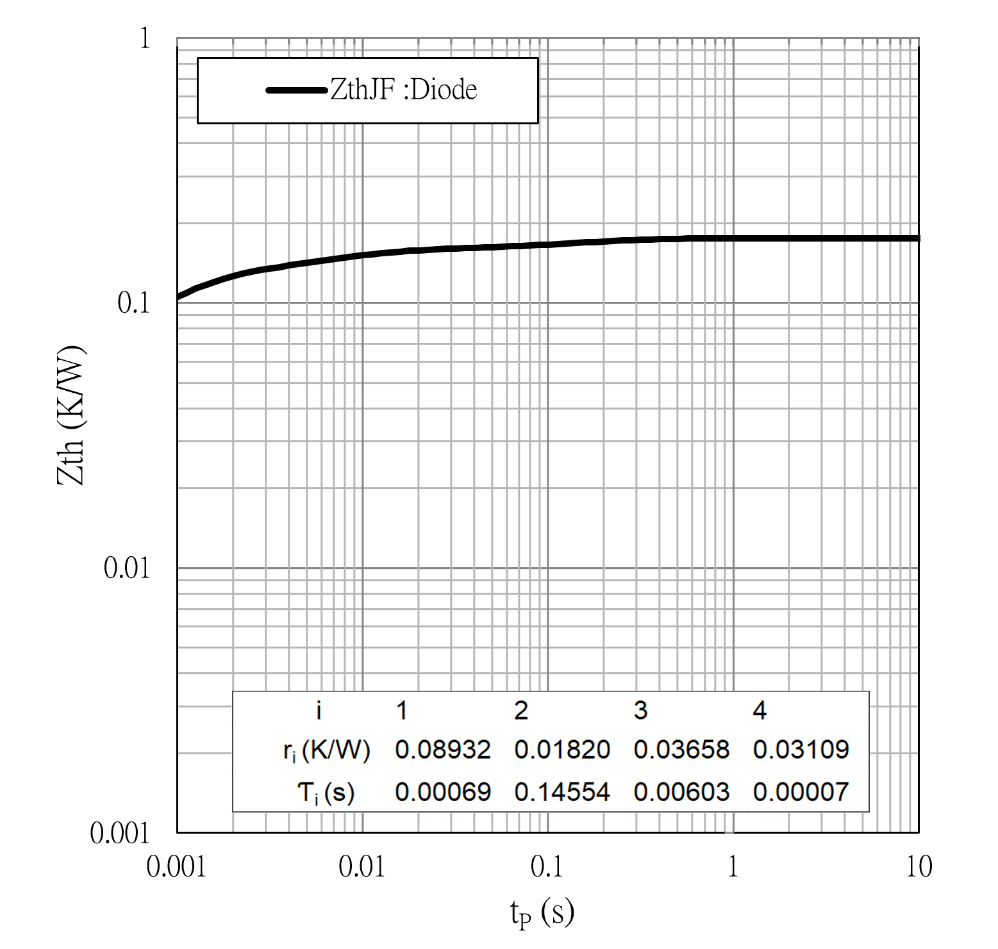



Package Outlines

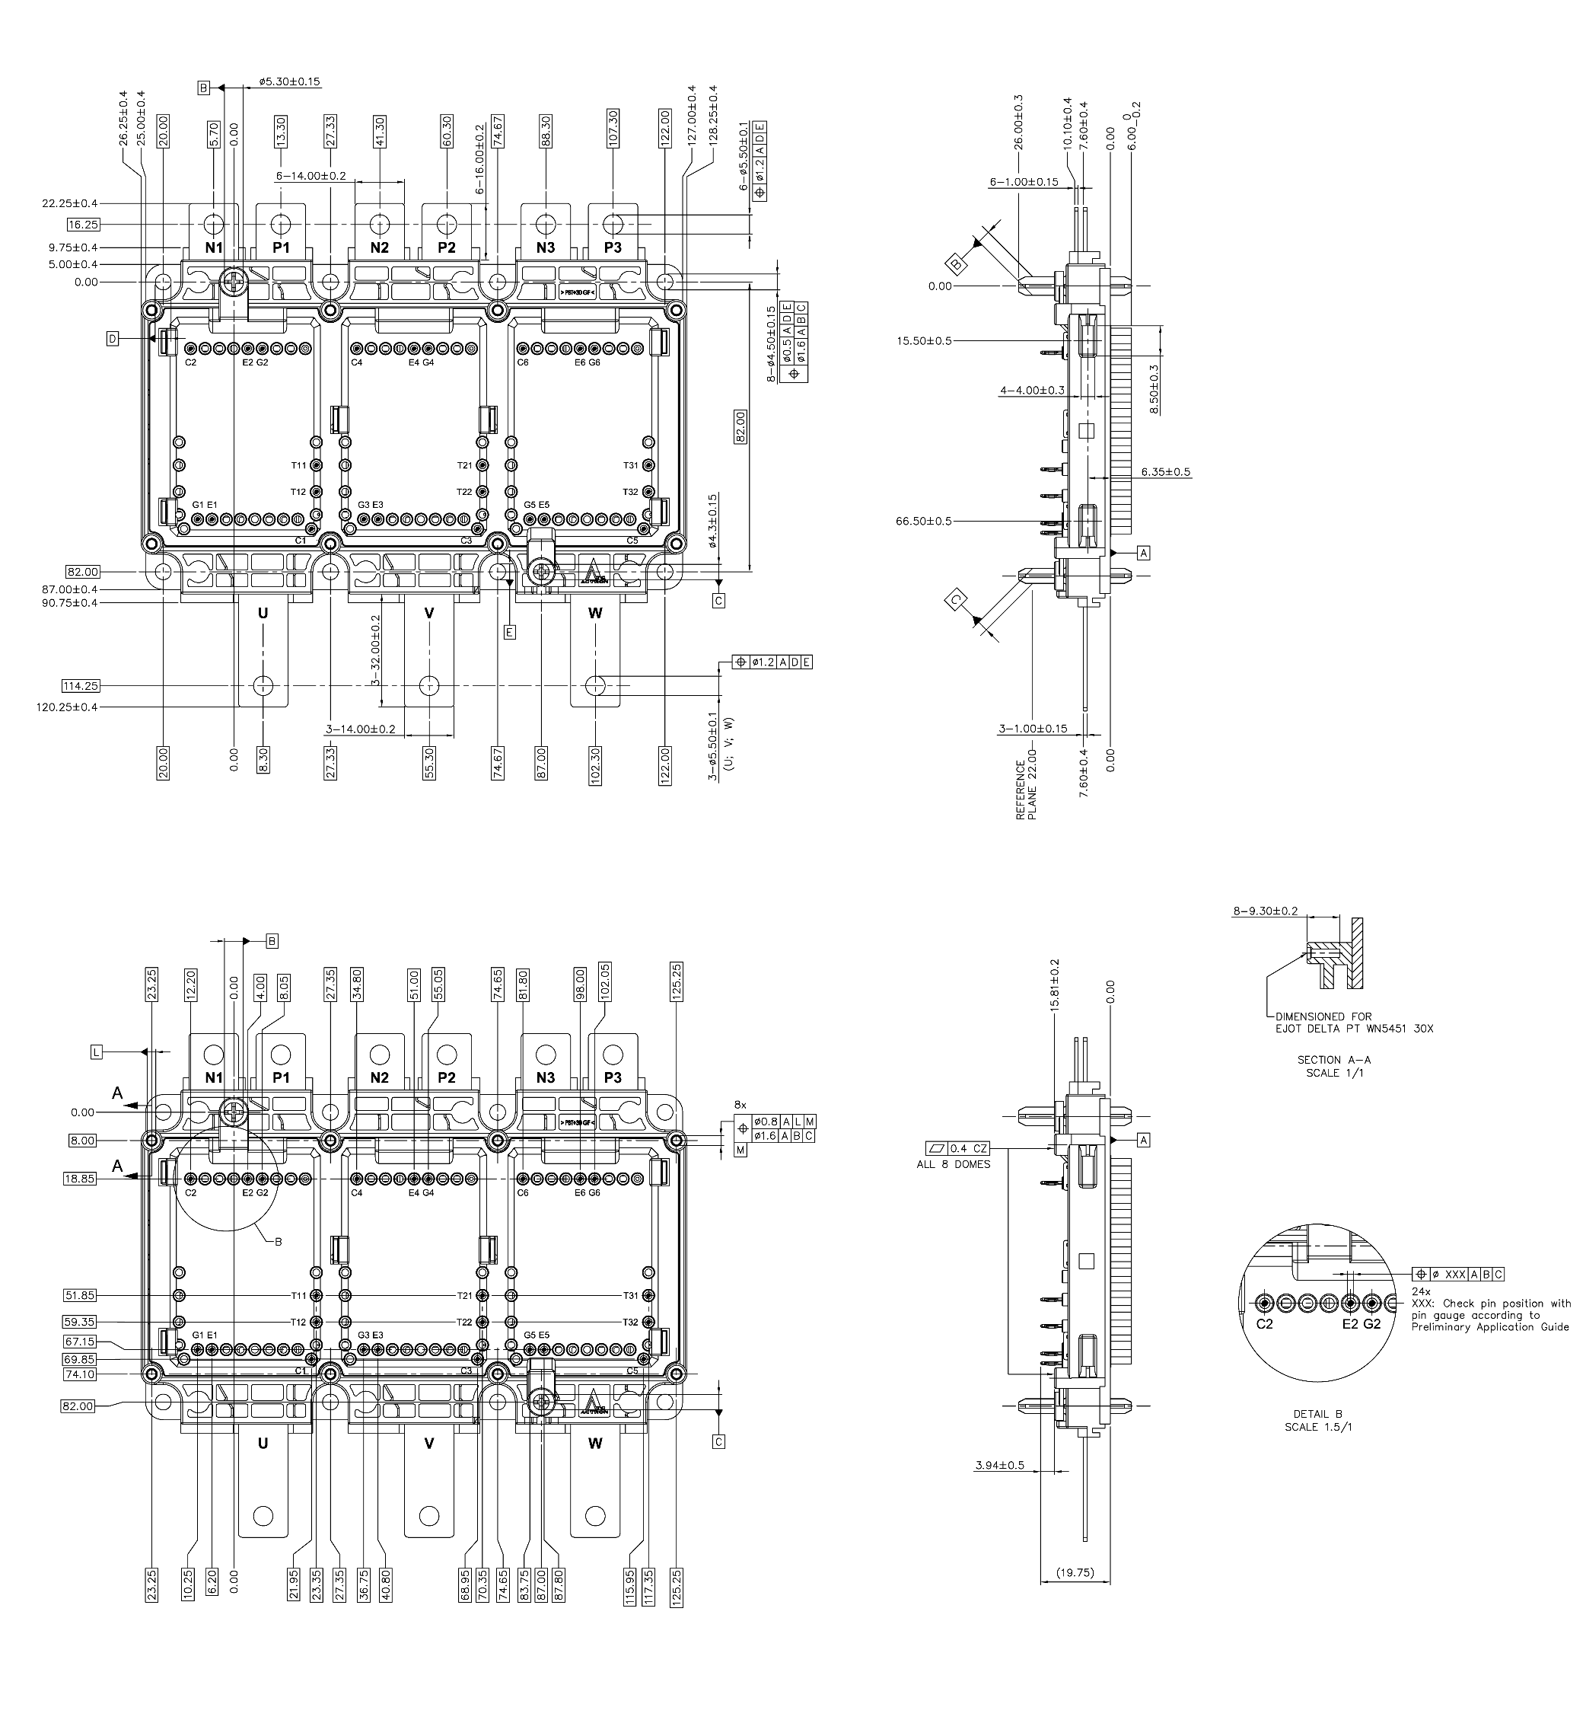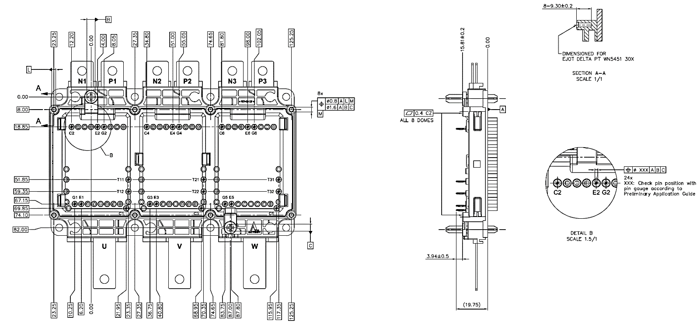

**IMPORTANT NOTICE AND DISCLAIMER**

**Edition 2024-09**

**Published by**

**Actron Technology**

**The information given in this document shall declare not to regarded as a guarantee of conditions or characteristics. With respect to any examples or hints given herein, any typical values stated herein and / or any information regarding the application of the device.**

**Actron technology provides such information, and other resources “as Is”, and disclaims all warranties, express and implied, including without limitation any implied warranties of merchantability, fitness for a particular purpose or non-infringement of third party intellectual property rights.**

**These resources are intended for skilled developers designing with Actron products. You are solely responsible for (1) selecting the appropriate Actron products for your application,**

**(2) designing, validating and testing your application, and (3) ensuring your application meets applicable standards, and any other safety, security, regulatory or other requirements.**

**For further information on technology, delivery terms and conditions and prices, please contact the Actron Technology. (https://www.actron.com.tw/tw)**

**Warnings Due to technical requirements, components may contain dangerous substances For information on the types in question, please contact the Actron Technology.**

**Actron Technology components may be used in special applications only with the express written approval of Actron Technology.**

**Trademarks of Actron Technology**

**Copyright © 2024 Actron Technology － All Rights Reserved.**



**Revision: 2024-September**